# Heuristic Analysis

## Optimal Plans

Problem 1: An optimal plan produced by BFS is:

Plan length: 6

Load(C2, P2, JFK)

Load(C1, P1, SFO)

Fly(P2, JFK, SFO)

Unload(C2, P2, SFO)

Fly(P1, SFO, JFK)

Unload(C1, P1, JFK)

Problem 2: An optimal plan produced by BFS is:

Plan length: 9

Load(C2, P2, JFK)

Load(C1, P1, SFO)

Load(C3, P3, ATL)

Fly(P2, JFK, SFO)

Unload(C2, P2, SFO)

Fly(P1, SFO, JFK)

Unload(C1, P1, JFK)

Fly(P3, ATL, SFO)

Unload(C3, P3, SFO)

Problem 3: An optimal plan produced by BFS is:

Plan length: 12

Load(C2, P2, JFK)

Load(C1, P1, SFO)

Fly(P2, JFK, ORD)

Load(C4, P2, ORD)

Fly(P1, SFO, ATL)

Load(C3, P1, ATL)

Fly(P1, ATL, JFK)

Unload(C1, P1, JFK)

Unload(C3, P1, JFK)

Fly(P2, ORD, SFO)

Unload(C2, P2, SFO)

## Results and Analysis

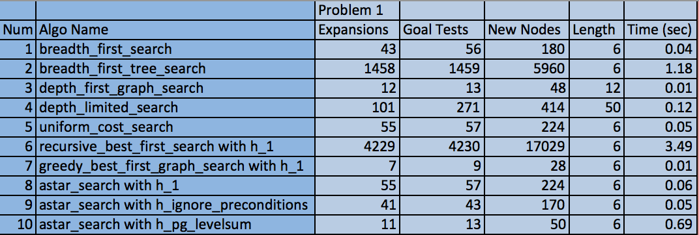

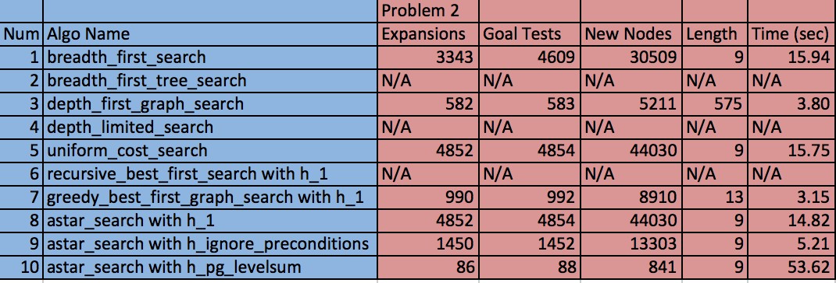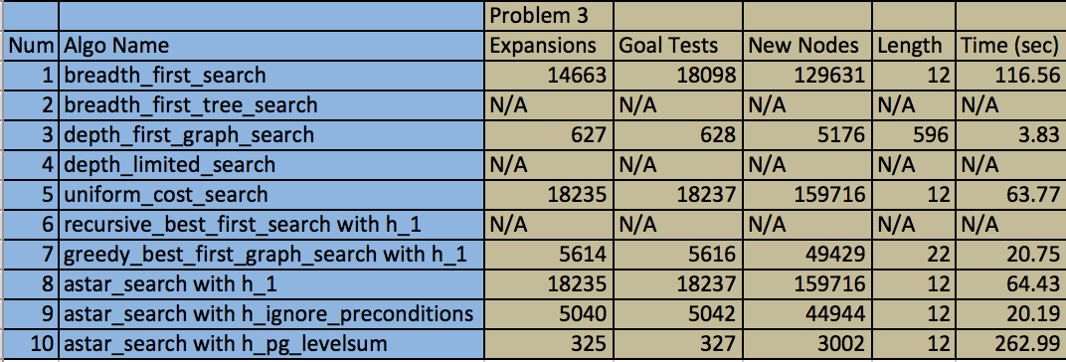

Non-heuristics: We choose to compare heuristics 1 (BFS), 3 (DFTS) and 5 (UCS). DFTS is the fastest but does not find an optimal plan for all problems. BFS and UCS are guaranteed to find an optimal path but are slower. In all cases, UCS expands more nodes than BFS; however, UCS is faster since the implementation of the priority queue is more efficient. Note that we notice that in problem 1 UCS is slightly slower than BFS, but we are interested in comparing the efficiency for more complex problems. Therefore problems 2 and 3 are more appropriate benchmark problems to compare algorithm efficiency. In theory, UCS time/space complexity should be larger than BFS; however, due to implementation details, UCS has a smaller time complexity. In particular, BFS stops as soon as it finds a goal, while UCS examines all the nodes at the goal’s depth to see if one has a lower cost. Therefore, UCS does more work by expanding nodes at depth d unnecessarily. Nonetheless, I will recommend the UCS for non-heuristic planning domains since it takes less time using the implementation I was given for this project.

Heuristics: We now compare 9 (IP) and 10 (LS). It’s clear that IP and LS heuristics provide significant reduction in the number of nodes expanded. In particular, the LS heuristic provides a more accurate heuristic than the IP heuristic (inferred by the difference in the number of nodes expanded); however, the time to compute the LS heuristic is much larger than the IP heuristic. For problem 3, the IP heuristic is able to expand approximately 2226 nodes per second, while the LS algorithm can only expand approximately 11 nodes per second. This huge reduction in node expansion efficiency outweighs the performance gain in reducing the number of nodes expanded. For these reasons, I recommend the IP algorithm.

Best heuristic: Overall, the ignore preconditions (IP) heuristic was the best for the reasons above. It significantly outperformed non-heuristic search planning methods for the more complex problems, namely problems 2 and 3. For problem 1, it still outperformed all non-heuristic search planning methods in terms of number of nodes expanded; however, it was 0.01 seconds slower than BFS. Overall the IP heuristic has a more substantial cost improvement for more complex problems. For these reasons, I recommend the IP search algorithm.